Touchscreen TS-9110 A(s)
New Central Control Editing Software V1.0
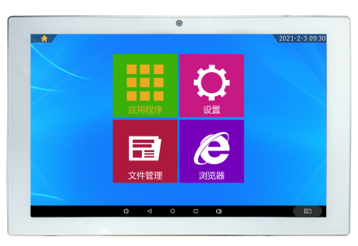
Product Introduction
This is a 10.1-inch capacitive touch all-in-one machine developed based on the Android system. The display screen is a 10.1-inch high-definition display with a resolution of 1280*800, providing delicate picture quality. It has a built-in 200W camera and speaker, supports PoE power supply, and can communicate and control with the central control system. It also has indicator lights to provide feedback on different scenarios. It is suitable for various mid-to-high-end conference rooms, control centers, and other occasions, making it a high-end human-machine interface device.

Features
- Thin body, overall thickness 27mm, one-piece high-precision molded middle frame.
- It has a built-in 200W camera and 2*1W speakers .
- Two RJ45 network interfaces, supporting gigabit network transmission.
- Supports multi-touch on capacitive screens.
- Full-view HD screen with a resolution of 1280*800 .
- It supports PoE power supply, simplifying wiring.
- Supports DC12V/2.6A power supply.

Technical parameters
CPU | RK3568, quad-core 64-bit, Cortex-A55, 2.0GHz
RAM | LPDDR-2G
Memory | EMMC-16G has a built-in (expandable TF card) slot.
operating system | Android 11.0
Display screen | LED backlit LCD screen (Grade A)
resolution | 1280*800
Visible area | 216.5*135 mm
Contrast | 2000:1
brightness | 300cd/m2
screen ratio | 16:10
touchscreen | 10.1-inch capacitive touchscree, supports 10-point touch mode, response speed ≤3ms
LED strip | I/O port protocol, built-in seven-color LED light strip
Media Playback | Video formats: MPEG-1, MPEG-2, MPEG-4, H.263, H.264, VC1, RV  Audio formats: MP3/WMA/AAC  Image format: jpeg
trumpet | 8Ω 1W×2
Camera | 200W front camera
Communication interface | One 10M/100M/1000M adaptive Ethernet
Back-out interface | Supports both Ethernet and RS-485 serial ports on the back, suitable for embedded installation.
Side control interface | Dry contact NO/NC/COM interface
Other interfaces | Two external USB 3.0 ports (one of which is USB_OTG).
WiFi/3G/4G/Bluetooth | Supports WIFI-2.4G and BT-4.1.
POE | Supported by IEEE 802.3at/af
powered by | Supports PoE/DC12V power supply
Overall power consumption | ≤12W
standby power consumption | ≤1W
Operating temperature | -5℃～45℃ (Screen operating temperature is 0℃-40℃)
Operating temperature | 0℃-40℃
Operating humidity | 30%～85%
Storage temperature | -10℃～50℃
Storage humidity | 10%～90%
Altitude | Below 2000 meters
color | silver
Gross weight (packaging) | 2kg
Packaging size (width × height × thickness) | 309*270*55mm
Weight | 1.3kg
Dimensions (L×W×D) mm | 253.5*163.5*30mm

Model Configuration Clarification
- The ITC TS-9110A product family is available in different factory configurations according to the technical specifications required for each order. The model TS-9110A identifies the standard configuration, while the model TS-9110A(s) identifies the factory-enhanced configuration that incorporates additional technical features installed by the manufacturer. Both configurations belong to the same TS-9110A product family and use the same base product platform.
- The letters (s) are factory configuration identifiers within the TS-9110A product family and are used for ordering, production, and product traceability purposes. The configuration letter does not represent a different product family.
- For this project, the TS-9110A system will be supplied in the TS-9110A(s) factory configuration, incorporating the following additional required technical features.

