Receiver T-591U(s)
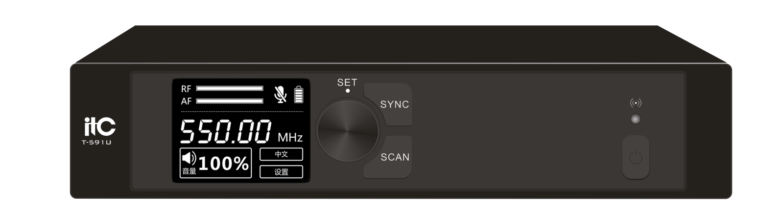
Description
It is a digital wireless microphone system with a new solution architecture. The system adopts digital U-band transmission technology, pi/4-DQPSK modulation mode, and uses ID code pilot technology to prevent cross-frequency interference, and frequency sweep to avoid interference, characterized by low bit error rate, stable transmission, and strong anti-interference ability. It can be widely used in conferences, training, public broadcasting, large-scale parties and other places.

Feature
Adopt unique digital U-band transmission technology, pi/4-DQPSK modulation mode, strong anti-interference ability, low bit error rate and stable transmission.
Adopting a unique encryption method for audio transmission to protect the content of the meeting.
Adopting unique ID code foreign frequency technology can prevent frequency interference.
Support one-click frequency scanning to avoid interference; one-click infrared frequency matching, easy to operate.
Support reverb, high, middle and bass adjustments.
Support one channel of balanced output and one channel of unbalanced output.
The receiver uses a 2.2-inch TFT-LCD screen to display information more delicately.
The receiver panel is made with exquisite craftsmanship and is elegant and beautiful.
The transmitting power is adjustable, adjust the transmitting power as needed.

Specification
Frequency range | 540MHz-590MHz、640MHz-690MHz
Receive sensitivity | ＜-95dBm
THD+N | ＜0.1%
Maximum output | Balanced output 500mV, unbalanced output 1000mV，unbalanced MIC output 50mV
SNR | ≥105dB（XLR）
Channels | ≥16
Frequency response | 20Hz~20KHz ±3dB
Dynamic range | ≥115dB
Antenna interface | BNC/impedance 50 ohms
Power supply | DC 12V/1A
Working current | ≤300mA
Dimensions (D×W×H) | 214×223.5×52mm
Weight | 1.32kg

Model Configuration Explanation
* T-591U – Standard Configuration
This is the standard version normally shown in the general product datasheet.
* T-591U(s) – Special Factory Configuration
* This is the same T-591U product family and the same basic equipment platform, but supplied from the factory with additional or enhanced technical characteristics available according to the customer's project requirements.
* The important point is that T-591U remains the main model family. The letters (s) only identify the specific factory configuration supplied under that model.

